N. UDAY KIRAN
192473001

1. Incorrect JOIN Syntax Returning Duplicate Results
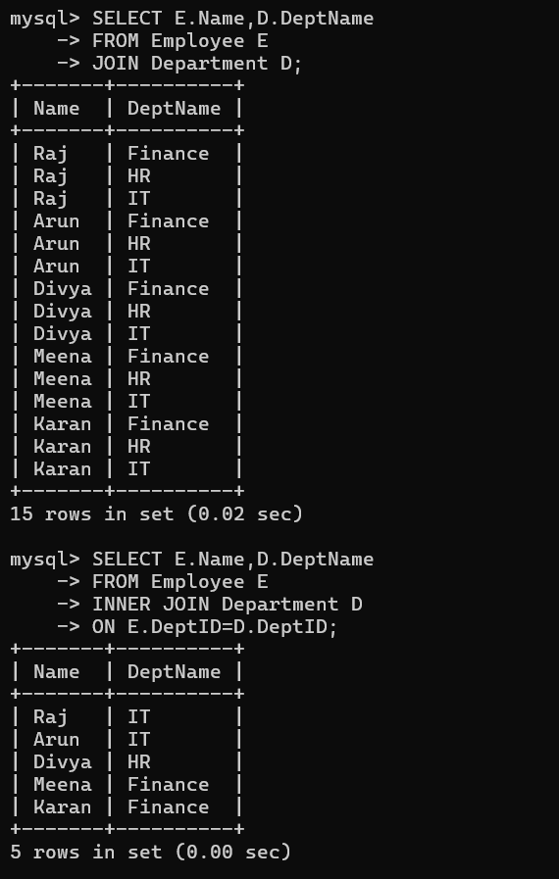

2. Missing Correlation in Subquery
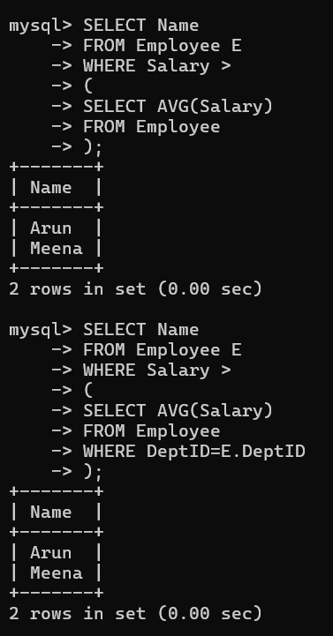

3. Incorrect SQL View
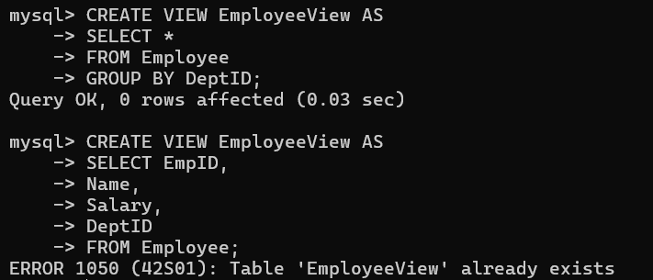
4. Incorrect Relational Algebra Natural Join
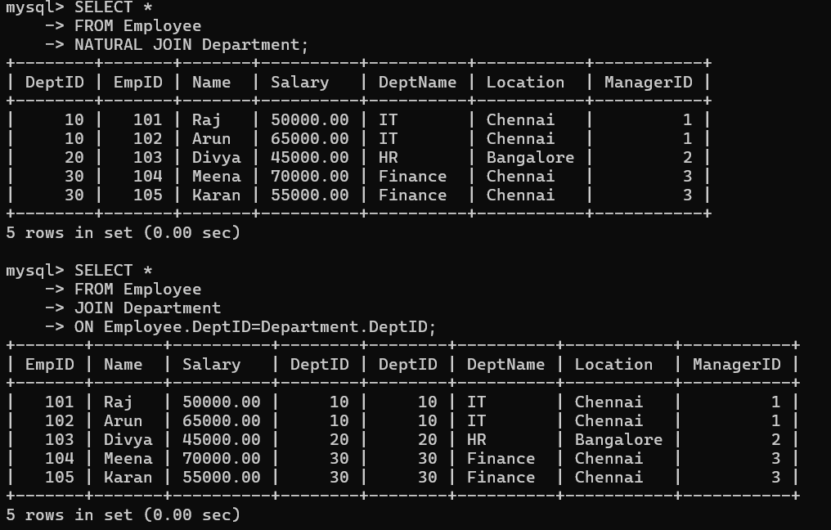

5. Referential Integrity Violation

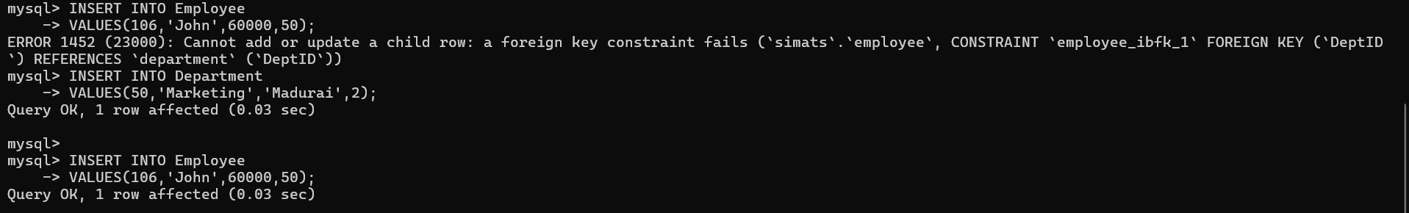

6. Nested Query Optimized Using JOIN
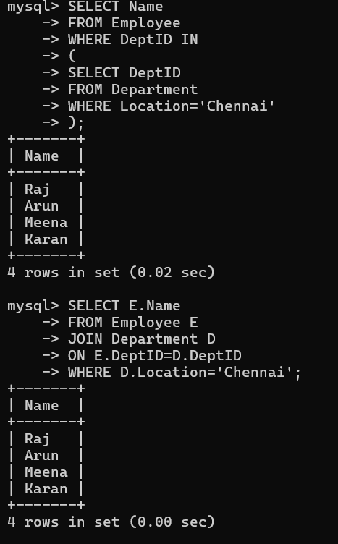

7.Incorrect GROUP BY
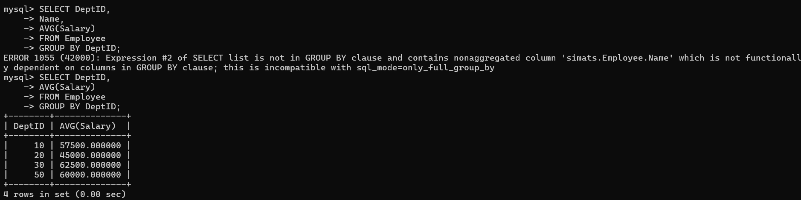

8. UPDATE Statement Modifies All Rows
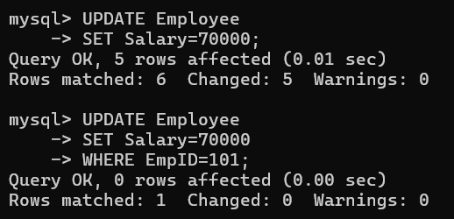

9. Optimize Multi-table Query
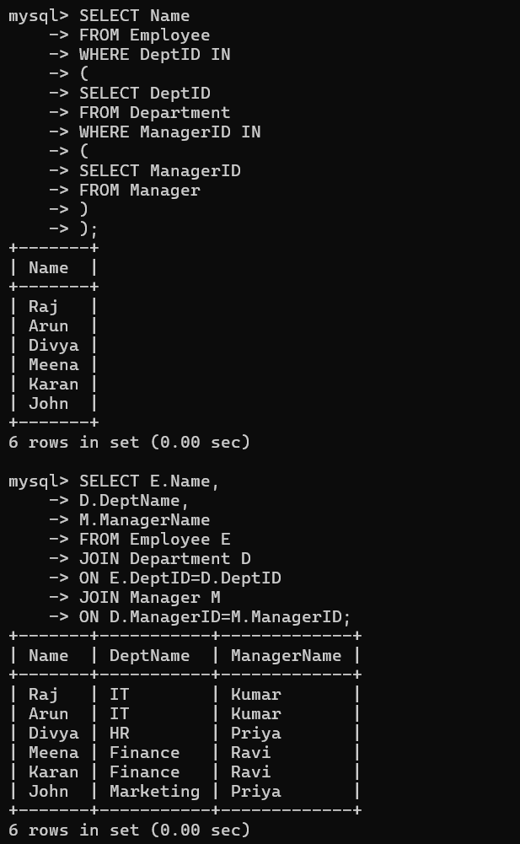

Question 10: Relational Calculus Equivalent SQL
